MediDoc:  
Universal Medical   
Database

Ankit Mishra 18BCE0780

Devina Varshney 18BCE0741

Navya Saxena 18BCE0770

Rishabh Kumar 18BCE0816

*Guided by*

*Prof. Navamani T M*

*Associate Professor*

**DATABASE MANAGEMENT SYSTEMS**

**COURSE CODE: CSE2004**

**SLOT: L51+L52**



Abstract

* Cloud computing is a new paradigm that is changing the way institutions, enterprises, organizations and people perceive and employ different software systems. Using cloud based solutions, organizations have neither the need to host their software, nor maintain their own servers.
* Cloud computing is defined as a model that conveniently allows network access on demand to a shared set of configurable resources that can be rapidly provisioned and released with minimal management efforts or interaction with a service provider.
* It provides functionality for managing information data in a distributed, ubiquitous and pervasive manner supporting several platforms, systems and applications and has brought about a transformation in the delivery model of information technology from a product to a service.
* Recently, patient safety and healthcare have gained high attention in professional and health policy-makers. This rapid growth causes generating a high amount of data, which is known as big data. Therefore, handling and processing of this data are attracted great attention. Cloud computing is one of the main choices for handling and processing of this type of data.

Objective:

* Aim

Using7 cloud computing we wish to create a website which stores the medical database of patients.

* Privacy

To maintain privacy, there will be two different logins for the hospital and the patient.

Motivation:

* Every person has been to a doctor at least once in their lives. During every visit, the doctor makes a local prescription and diagnoses the patient with something.
* After the prescription is over, the patient loses track of all the medicines and doses he or she took. If some time in the future, the patient is admitted under a different doctor and requires to show their past prescriptions, they might not have it.
* So it becomes difficult for the doctor to prescribe new medicines which won’t react with the past ones.
* We aim at changing such distress situations.
* Creating a database of all patients including their past diagnoses:
  + under which doctor they got treated
  + where they got their treatment done
  + what kind of treatment
  + medicines prescribed
  + diseases or infections they had
* This database can be accessed by all doctors and patients all over the country.
* Privacy of a person is the most important thing. So we came up with an idea to make sure that wrong information is not added to the database.
* Only the administration of the hospital can edit the database, but to stop them from accessing anyone’s data, each patient will have to enter their username and password which will be required to edit their information.
* This way we can prevent misuse of the database.

Literature Survey:

1. **Comparison of Cloud Database: Amazon’s SimpleDB and Google’s Bigtable**

IJCSI International Journal of Computer Science Issues, Vol. 8, Issue 6, No 2, November 2011

* Traditional Databases & their issues
* Cloud Databases
* Widely used Cloud Databases (SimpleDB and Google’s Bigtable)
* Advantages and Drawbacks of SimpleDB
* Advantages and Drawbacks of Google’s Bigtable

**Techniques**

* Traditional Databases get harder to handle as the size of the organization grows. It also has the drawback of relying on a single localized server or machine, which might lead to data loss, in case of failure of the machine .
* Amazon’s SimpleDB is a web service that can provide you the core database features like speedy, real time lookup and querying of structured data techniques. It eliminates much of the drawbacks traditional databases have.
* A Bigtable is a light, scattered, constant multidimensional sorted map. Indexing of the map is done by a row key, column key, and a timestamp. In Bigtable, un-interpreted arrays of bytes are used as values. Bigtable stores structured data . It’s a service provided by Google.

**Drawbacks**

**Amazon’s SimpleDB**

▪ No guaranteed data integrity.

▪ Inconsistency can offer a terrible user experience.

▪ Collective operations will require more code.

▪ Complex reports, and ad hoc queries, will need excessive coding.

▪ Aggregate operations will be comparatively much slower if RDBMS is not used.

▪ Importing and exporting data and backup will be slow and complex.

▪ SimpleDB is not that quick.

▪ Relational databases are measurable, even with huge datasets.

▪ Super-scalability is overestimated. Slowing the pace of the Product development is even worse.

▪ SimpleDB is significant only in certain contexts.

**Google’s BigTable**

▪ It is not an open source database.

▪ Does not support final consistency.

▪ Capability of queries is limited.

▪ Inadequate access control.

▪ Requires adaptation to the Bigtable approach for application writing.

▪ Demands manual query programming as Structure query language is not supported by Bigtable.

▪ No support for ACID transactions as used in RDBMS

1. **Attribute Based Access Control in Personal Health Records Using Cloud Computing**Supriya D. Patil, Komal S. Talekar, Reshma M. Raskar, Pooja A. Chavans, Prof. Rupali Kadu

Volume: 05 Issue: 03 | Mar-2018

**While, the paper Covers a wide range of topics, The Major Outline of the same is as follows-**

* Patient centric access control for sharing of Personal Health Record (PHR).
* Eliminating reasons for not relying on cloud computing for managing health records.
* We can dynamically update information of a patient after he/she gets treated on cloud.
* We can share records over cloud for future reference.

**Techniques**

* The Attribute Based Encryption (ABE) technique is employed that during which the PHR owner encrypts the data according to associate degree access policy which determines the potential users UN agency are eligible to access.
* Storing PHR information in Third-Party Cloud in encrypted format.
* The access policy involved solely allows those users having a secret key related to set of attributes that satisfies the policy will be capable of decrypting it.
* A mix of anonymization techniques like k-Anonymity, l-Diversity & t-Closeness is applied to cut back the Re-Identification Risk and thence the privacy of the patients is preserved.

**Drawbacks**

* There is a need for fast access to internet.
* Records are limited to branches of the hospital.
* Maintaining a Cloud Storage is costly for a single firm.
* Threat to privacy of a patient.

**Context matters: A review of the determinant factors in the decision to adopt cloud computing in healthcare**

Fangjian Gao, Ali Sunyaev

International Journal of Information Management

Released in 2019

**While, the paper Covers a wide range of topics, the Major Outline of the same is as follows-**

* Specificities of cloud computing adoption in healthcare.
* Conceptual framework and recommendations for future research.
* Determinant factors for cloud computing adoption in healthcare.
* Duality of cloud computing characteristics in healthcare.
* Cloud computing as a derivative of IT outsourcing.
* Cloud computing as representative of IT innovation.

**Techniques**

* With its unique IT service paradigm, CC can enhance traditional health IT approaches. According to Mell and Grance (2011), who provide the most acknowledged definition of CC in the domain of IS, CC provides three service models: infrastructure as a service (IaaS), platform as a service (PaaS), and software as a service (SaaS).
* CC can deliver fundamental IT resources (through IaaS); IT platforms with programming languages, tools, and/or libraries for software development or deployment (through PaaS); or ready-to-use software applications that run on cloud infrastructure (SaaS) to healthcare organizations.
* The service paradigm enables CCSs to possess five unique essential technical features: on-demand self-service, resource pooling, rapid elasticity, broad network access, and measured service.

**Drawbacks**

* This paper tries to generalize healthcare database across the world but the healthcare systems of different countries like Belgium, China, Canada, Denmark, Great Britain, France, Germany, Norway, Saudi Arabia, USA are heterogeneous .
* this research does not investigate the prioritization of the determinant factors, their categories, or the correlations between them, which could also depend on different regions of healthcare organizations and influence the selection and use of the determinant factors.
* The topic of health IT is by nature multidisciplinary and involves additional areas such as medicine, management, economics, or law but this paper has focussed on IS and MI.

1. **Cloud Security: Concepts, Methodologies, Tools, and Applications**

*Noted as an IGI Global Core Reference Title in Computer Science & IT for 2019.*

*Information Resources Management Association*(USA)

Release Date: April, 2019

**While, the paper Covers a wide range of topics, The Major Outline of the same is as follows-**

* + - Big Data Security
    - Cloud Forensics
    - Cloud Intrusion Detection
    - Cloud Services
    - Governance and Risk Management in the Cloud
    - Information privacy
    - Secure Wiping Extensions
    - Security Using Data Mining Techniques
    - Standardization and Security in the Cloud

**Techniques**

* A Multi-Dimensional Mean Failure Cost Model to Enhance Security of Cloud Computing
* A Secured Real Time Scheduling Model for Cloud Hypervisor
* Runtime Reusable Weaving Model for Cloud Services Using Aspect-Oriented Programming: The Security-Related Aspect
* Healthcare SaaS Based on a Data Model With Built-In Security and Privacy
* Security Model for Mobile Cloud Database as a Service (DBaaS)
* A Credible Cloud Service Model Based on Behaviour Graphs and Tripartite Decision-Making Mechanism

**Drawbacks**

One major security issue related to the cloud is the DDoS attack.

Distributed Denial of Service (DDoS) attack can simply duplicate its source address, such as spoofing attack, which defending methods aren’t able to disguise the real location of the attack.

The paper discusses this issue under

* + DDoS Attacks and Defense Mechanisms in Cloud and Fog Computing
  + Multi-Aspect DDOS Detection System for Securing Cloud Network

**Summary of drawbacks or Issues in existing system**

* One major security issue related to the cloud is the DDoS attack.
* There are no measures for consistent database.
* Till now its just limited to Intra-Hospitals (Between same hospitals like Fortis or Tata Memorial).
* Chances of illegal access to patient’s data and manipulating it.
* System is so complex that it’s hard to understand and used by illiterate.
* Keeping a cloud network is costly for a single firm.

**Proposed System**

To implement our project, we have come up with the idea to create the database using MySQL and integrate it with a user-friendly website. To do so, we will follow the basic structure of creating the database in MySQL.

* Create database
* Create table for patients, diseases, location, hospital administration (credentials to check).
* Primary Key – user ID
* Specific attributes of each table are yet to be decided, but would majorly include :
  + Name of the user
  + Password
  + Location
  + Disease encountered
  + Recovery time
  + Medicines prescribed
  + Basic information of the user like current address, gender, age, etc.
* To create the website, we are going to use HTML, CSS and JavaScript.
* Landing page – the first page the user would come across.
* Login Page – To enter the credentials of the hospital administration or patient. Need username and password so that respective page would be loaded.
* Patient page – can only read the database.
* Hospital administration page – can write in the database, but would require patient’s username and password to edit the database.
* Contact info – contact information of the developers.
* Team

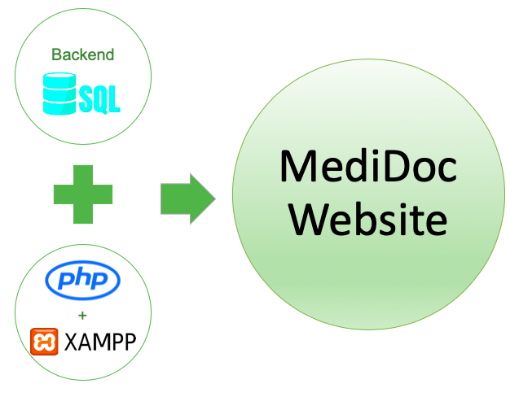

Fig 1: System architecture

In Fig 1, the database, which stores the details of the patients, admin, doctors, dependents, and medical history, has been created using SQL. With the help of Xampp software, we use php files to connect the front-end to the SQL database. Together they form a user friendly website which can be used by patients and administrators alike.



Fig 2: Functional architecture

Fig 2 shows the Entity Relationship model of the database. Table Patient, Medical History, Doctor and Admin are strong entities whereas Table Dependent is a weak entity. Cardinality ratios have been mentioned.



Fig 3: Modular design

In Fig 3, Flow of modules has been shown. From the home page, the user is directed to login page. The user can be an administrator or a patient and they have their separate pages. The Patient can view their profile, dependents and medical history. The administrator can view their profile, and a specific medical history by searching for a unique patient id. The administrator can also insert new patient record, but dual authentication is required, i.e. unless the patient id and his password match the ones in the database, the new record will not be inserted into the SQL database.

**Innovative Idea**

* Universal Database- Companies aim to increase their database for their personal growth, this system ensures uniform sharing of data by all the agencies, which leads to a far superior medical aid.
* Dual Authentication- Ensuring that the data of patients does not fall in the wrong hands , and creating a safe and reliable cloud based database.
* Web-Based Platform- Web insures it is easily accessible by anyone with a device, unlike traditional software.
* Safety – The system ensures, that only authorized people get access to the data of the patients, on the other hand, Traditional Databases could be hacked as they are not as secure as cloud based platforms.

**Implementation Details and Analysis**

* Implementations of this category of software’s have previously been in a traditional windows or a specific platform based software, which cannot be run independent of the specific platform .
* The software has been based on a web-based platform to ensure that the application can be accessed independent of the platform . A web based solution also ensures that the patients can access their data from any device, thereby enhancing ease of accessibility.
* The web application is based on the popular web application development tools like HTML, CSS , PHP , Xampp, SQL, Bootstrap and JavaScript .
* The landing page redirects the users into two different login pages for the admin and the user respectively. The admin of the hospitals and the users get different privileges when it comes to the database, while the admin is allowed to add on new records, the patient is only allowed to view his medical records.

**Software details and screenshots with respective Description**

* The software is a web based platform, which carries out all the functions like authentication, retrieving query from the database and many more. This is based on a modern user interface called the material UI, which enhances the overall appearance of the website.
* The screenshots of the website:

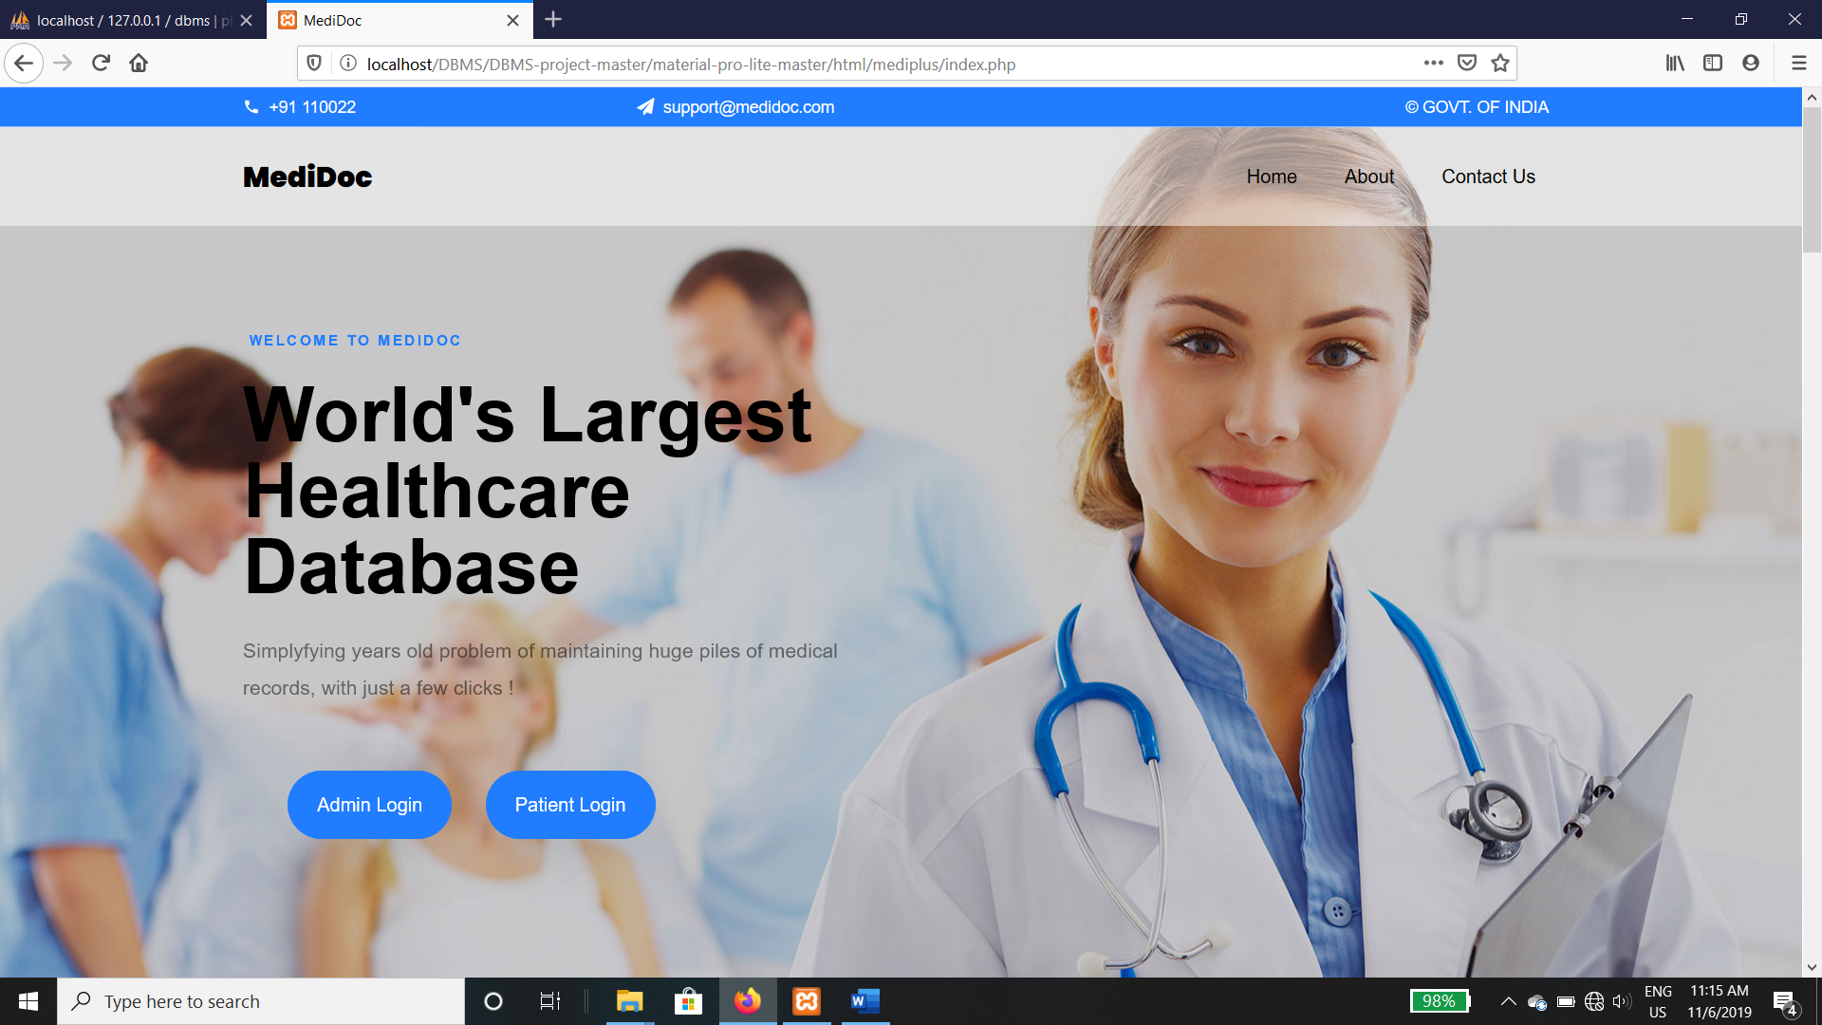

Fig 4

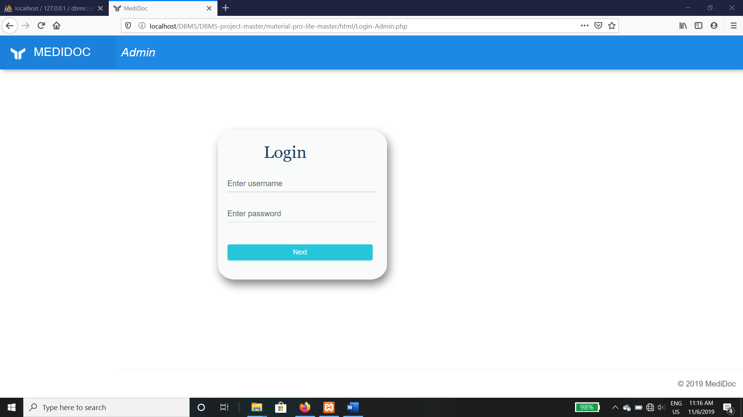

Fig 5

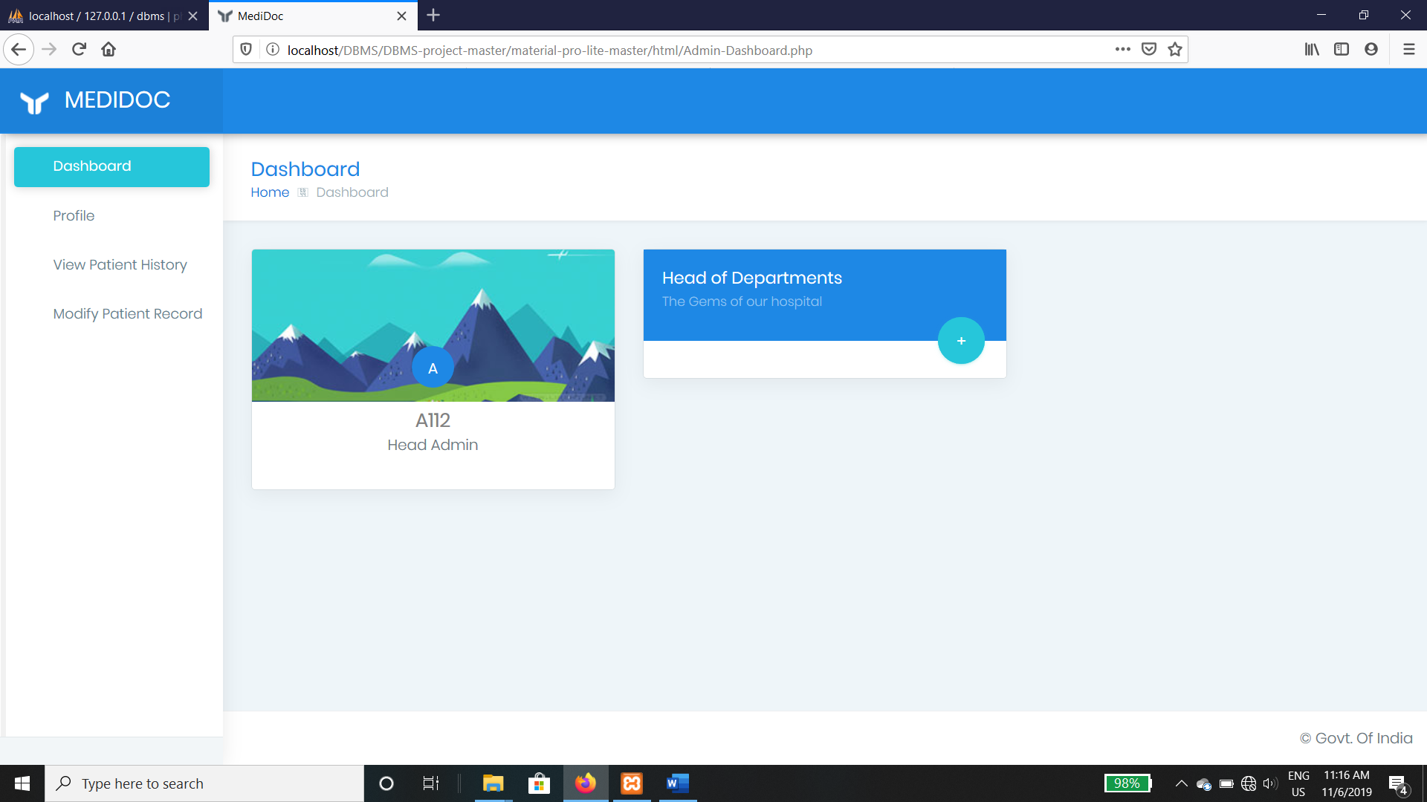

Fig 6

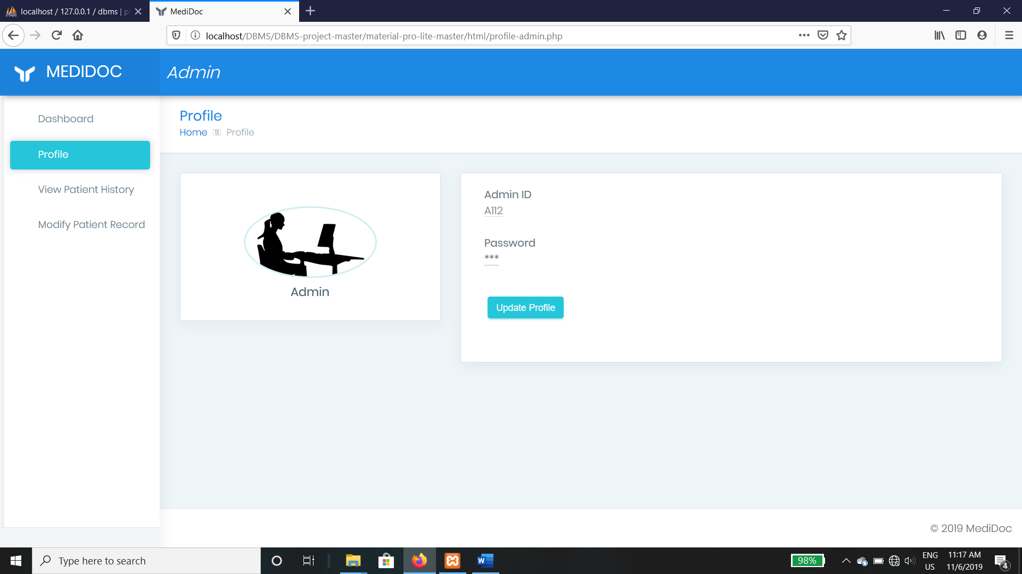

Fig 7

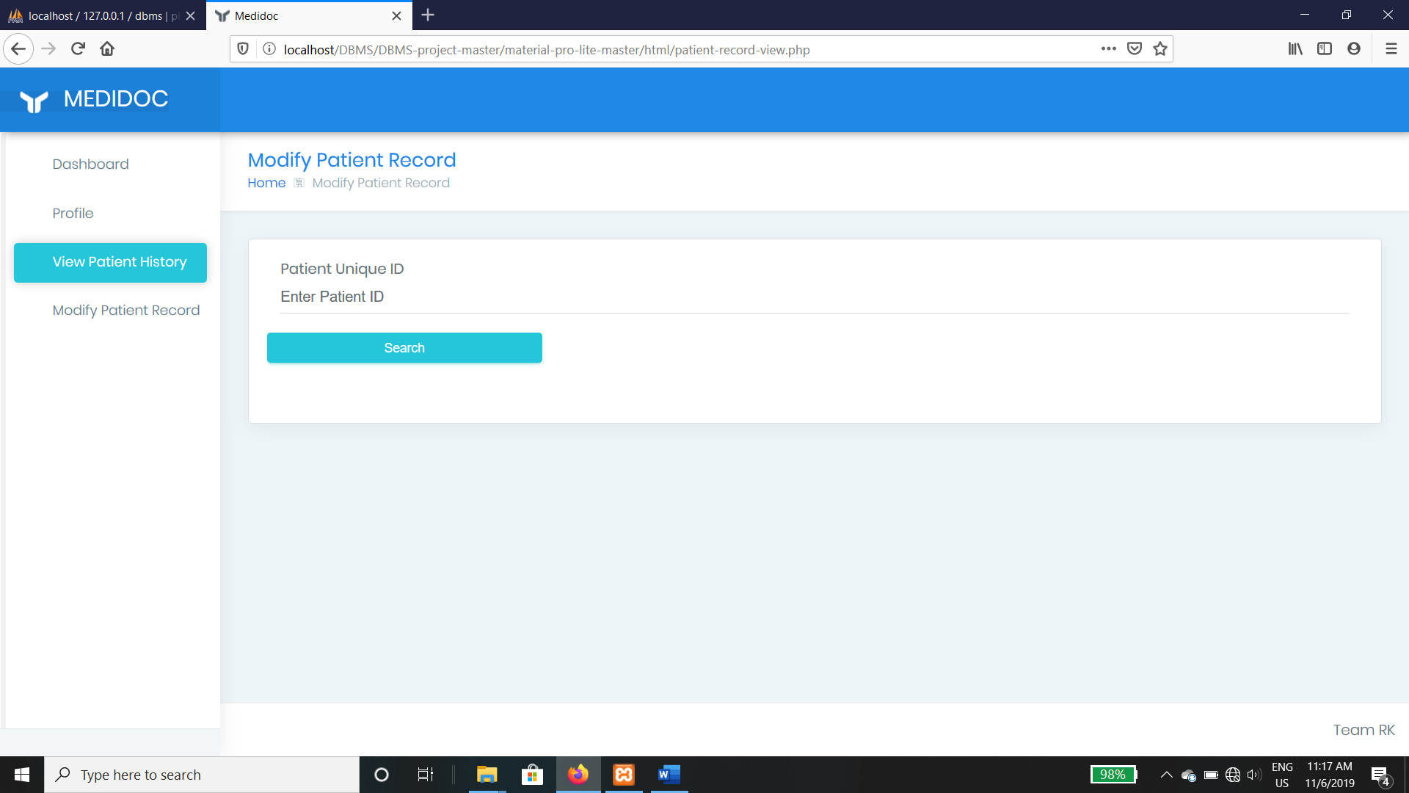

Fig 8

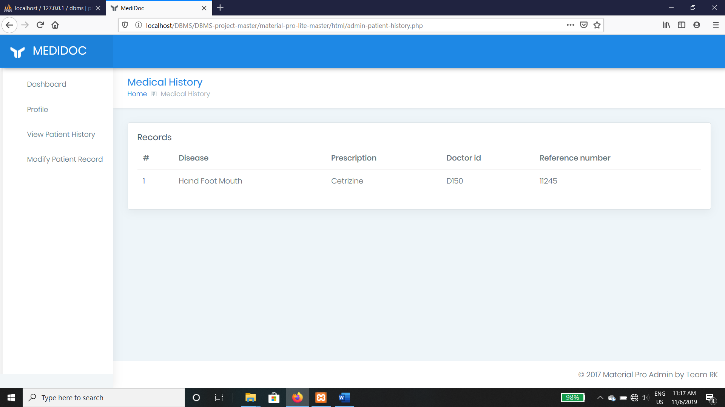

Fig 9

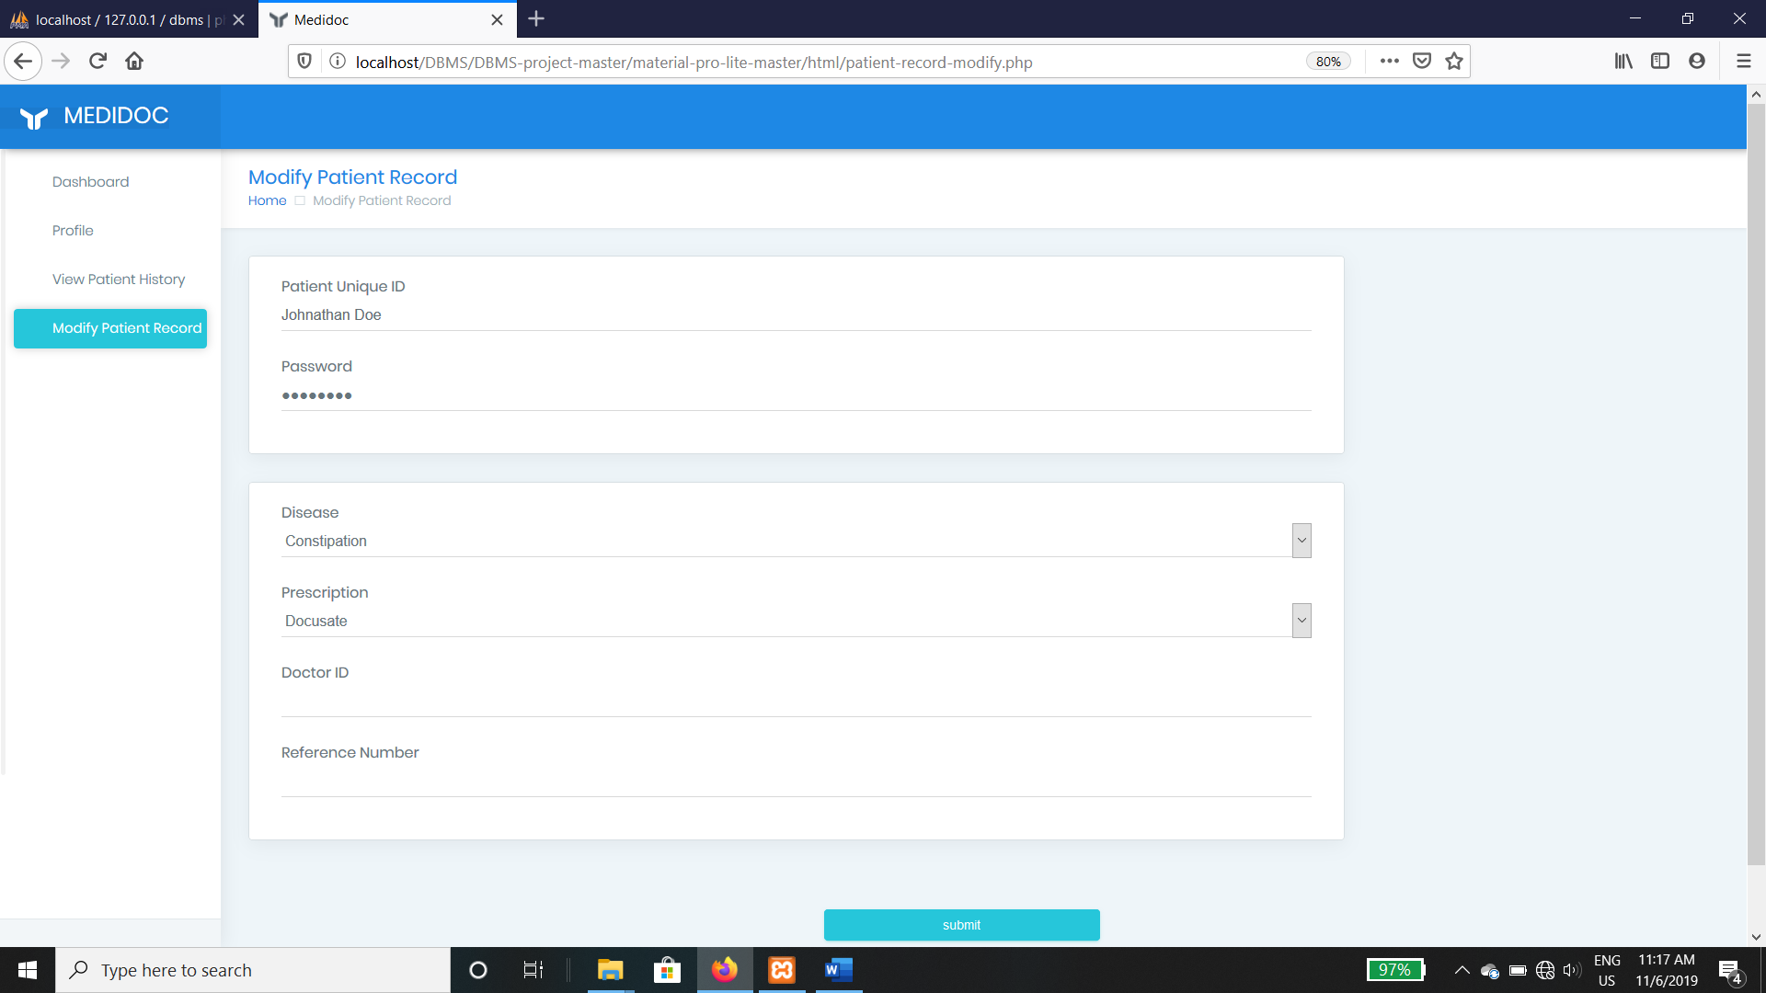

Fig 10

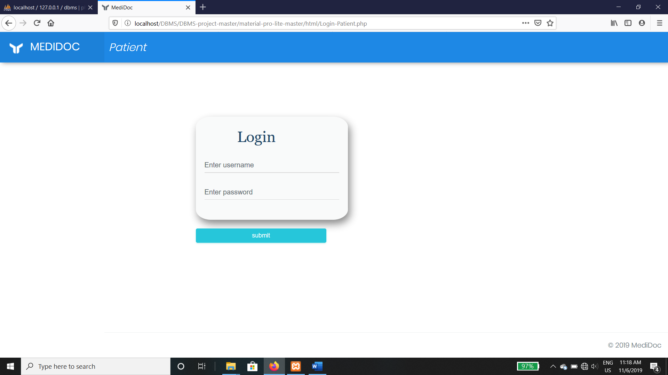

Fig 11

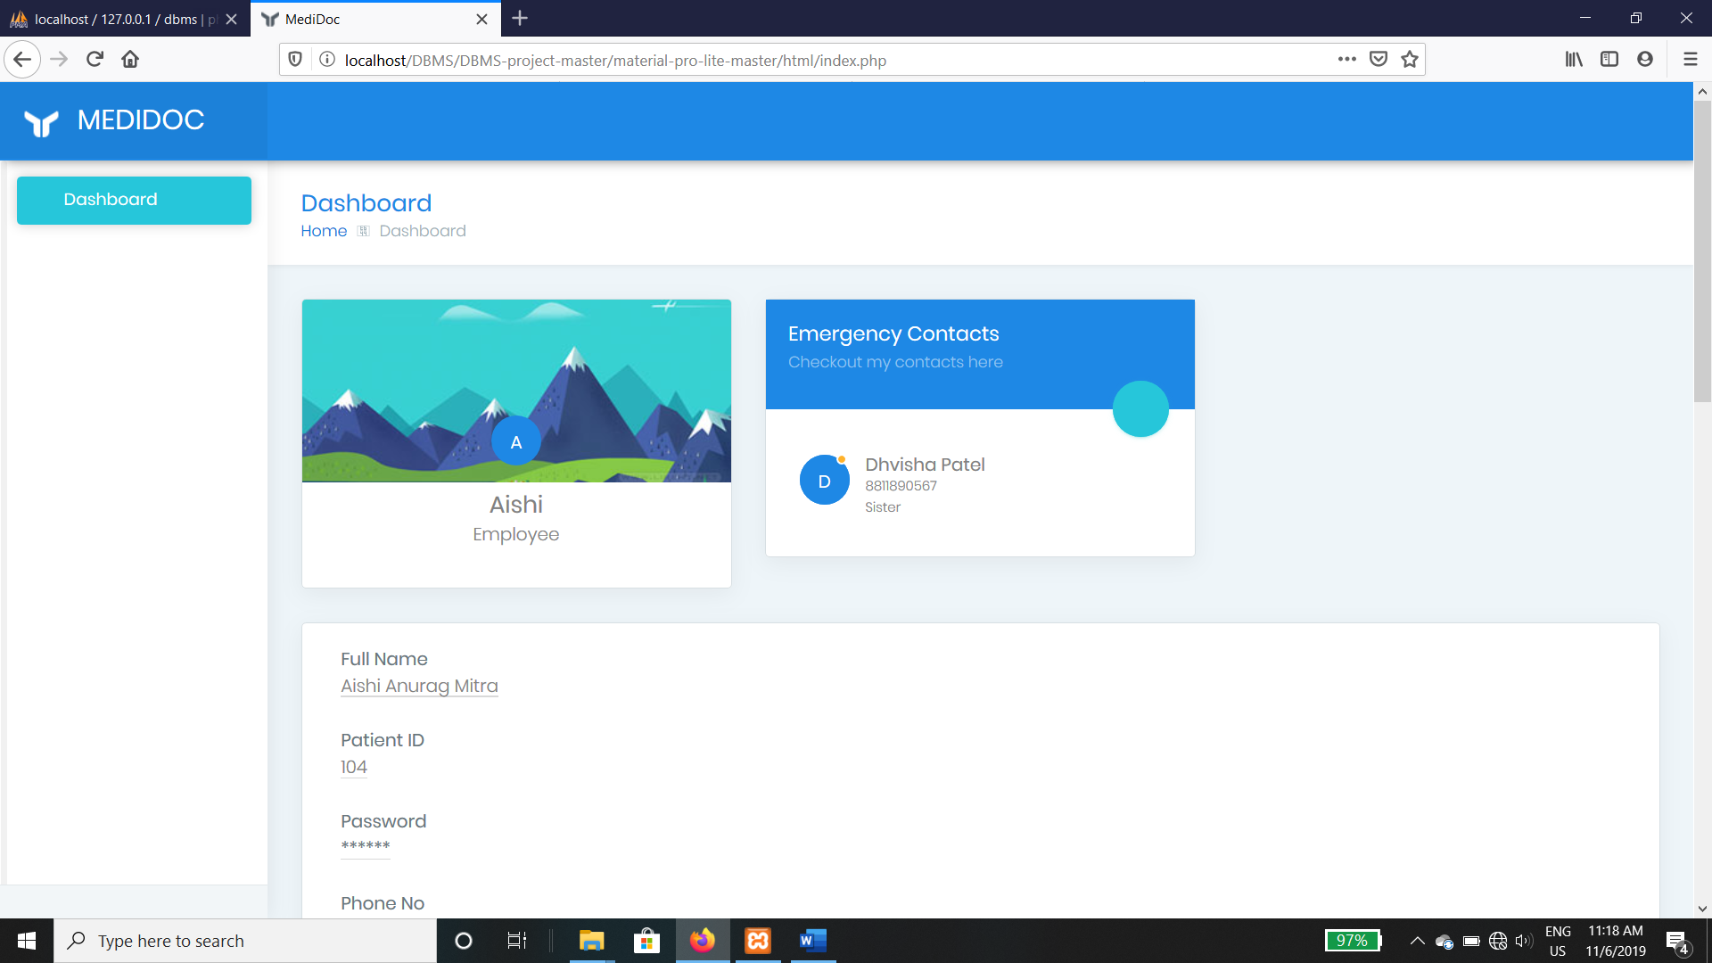

Fig 12

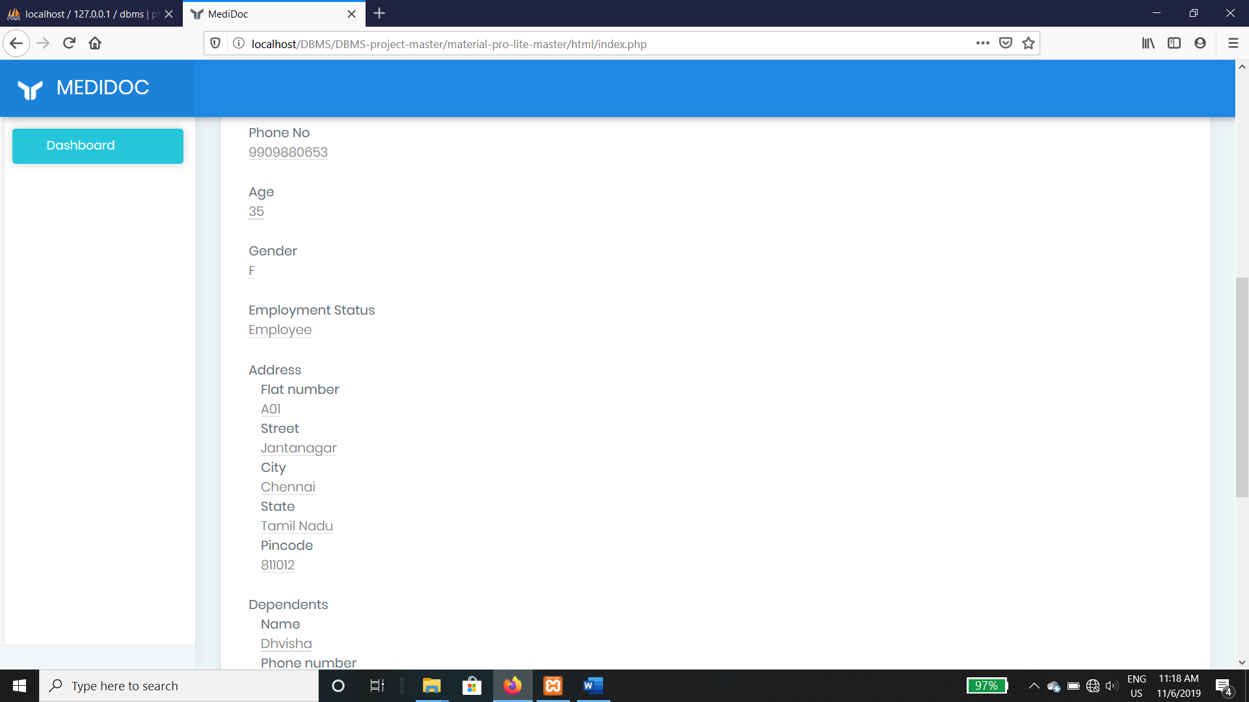

Fig 13

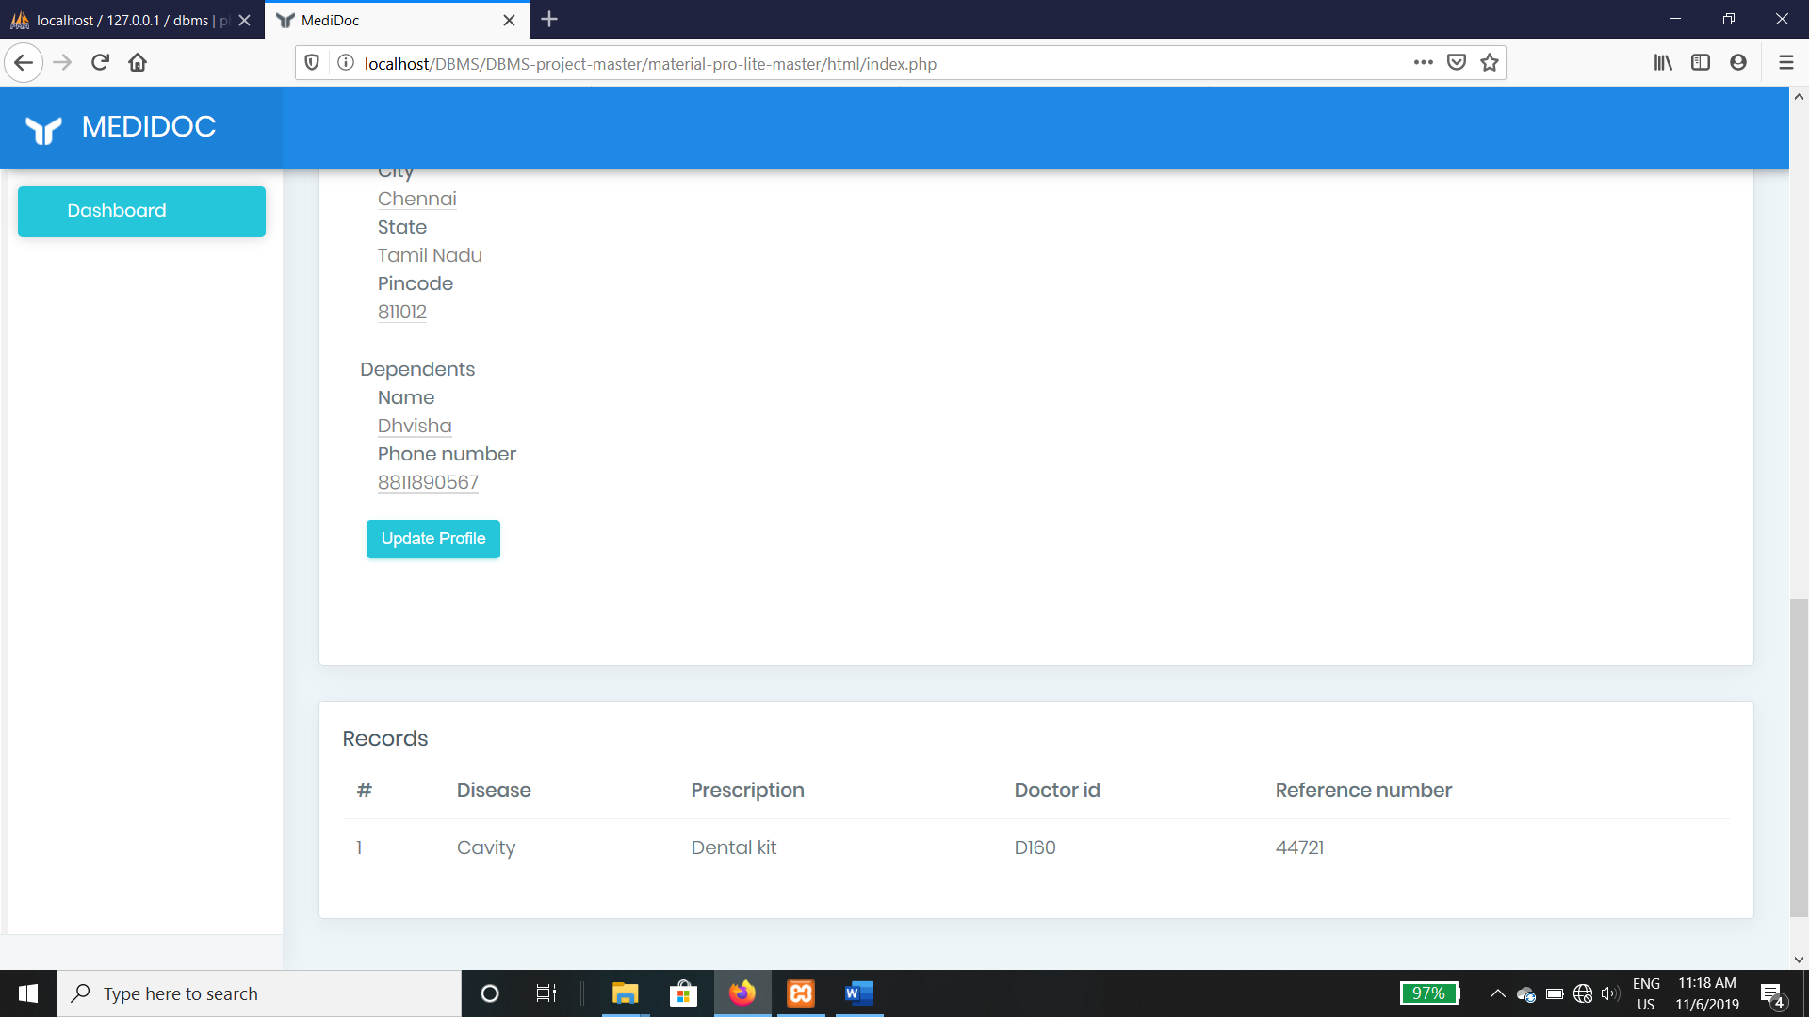

Fig 14

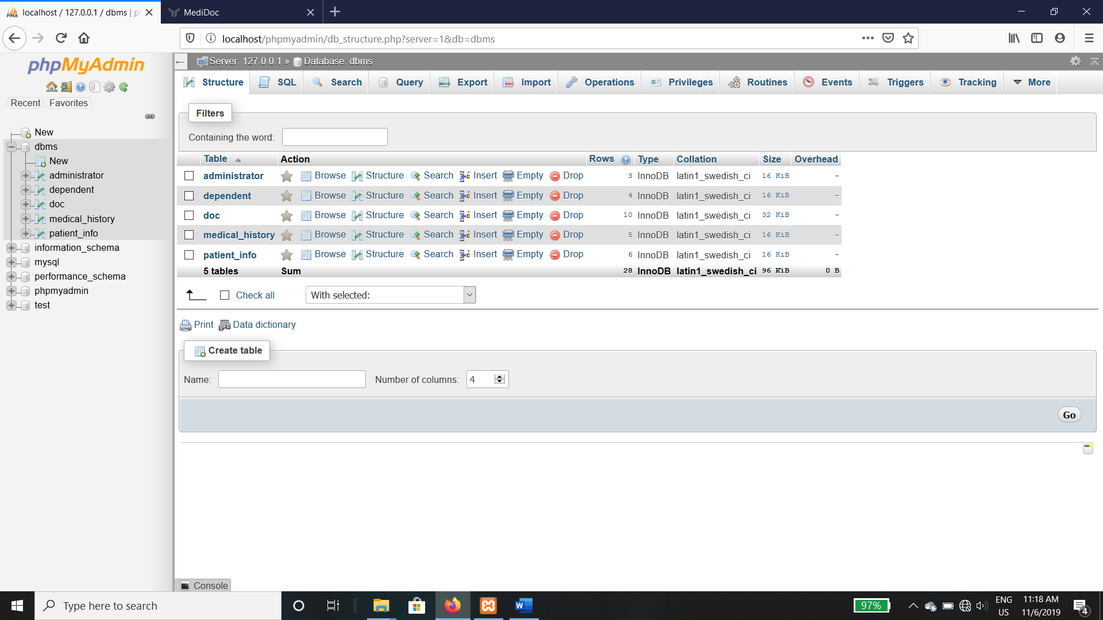

Fig 15

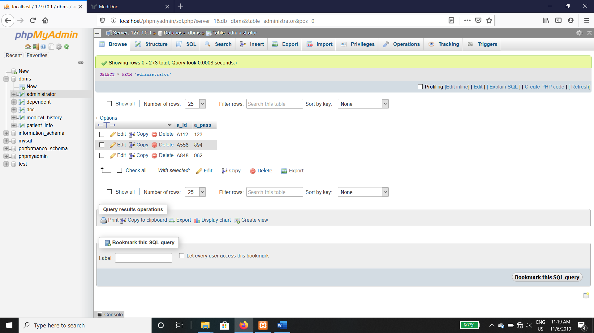

Fig 16

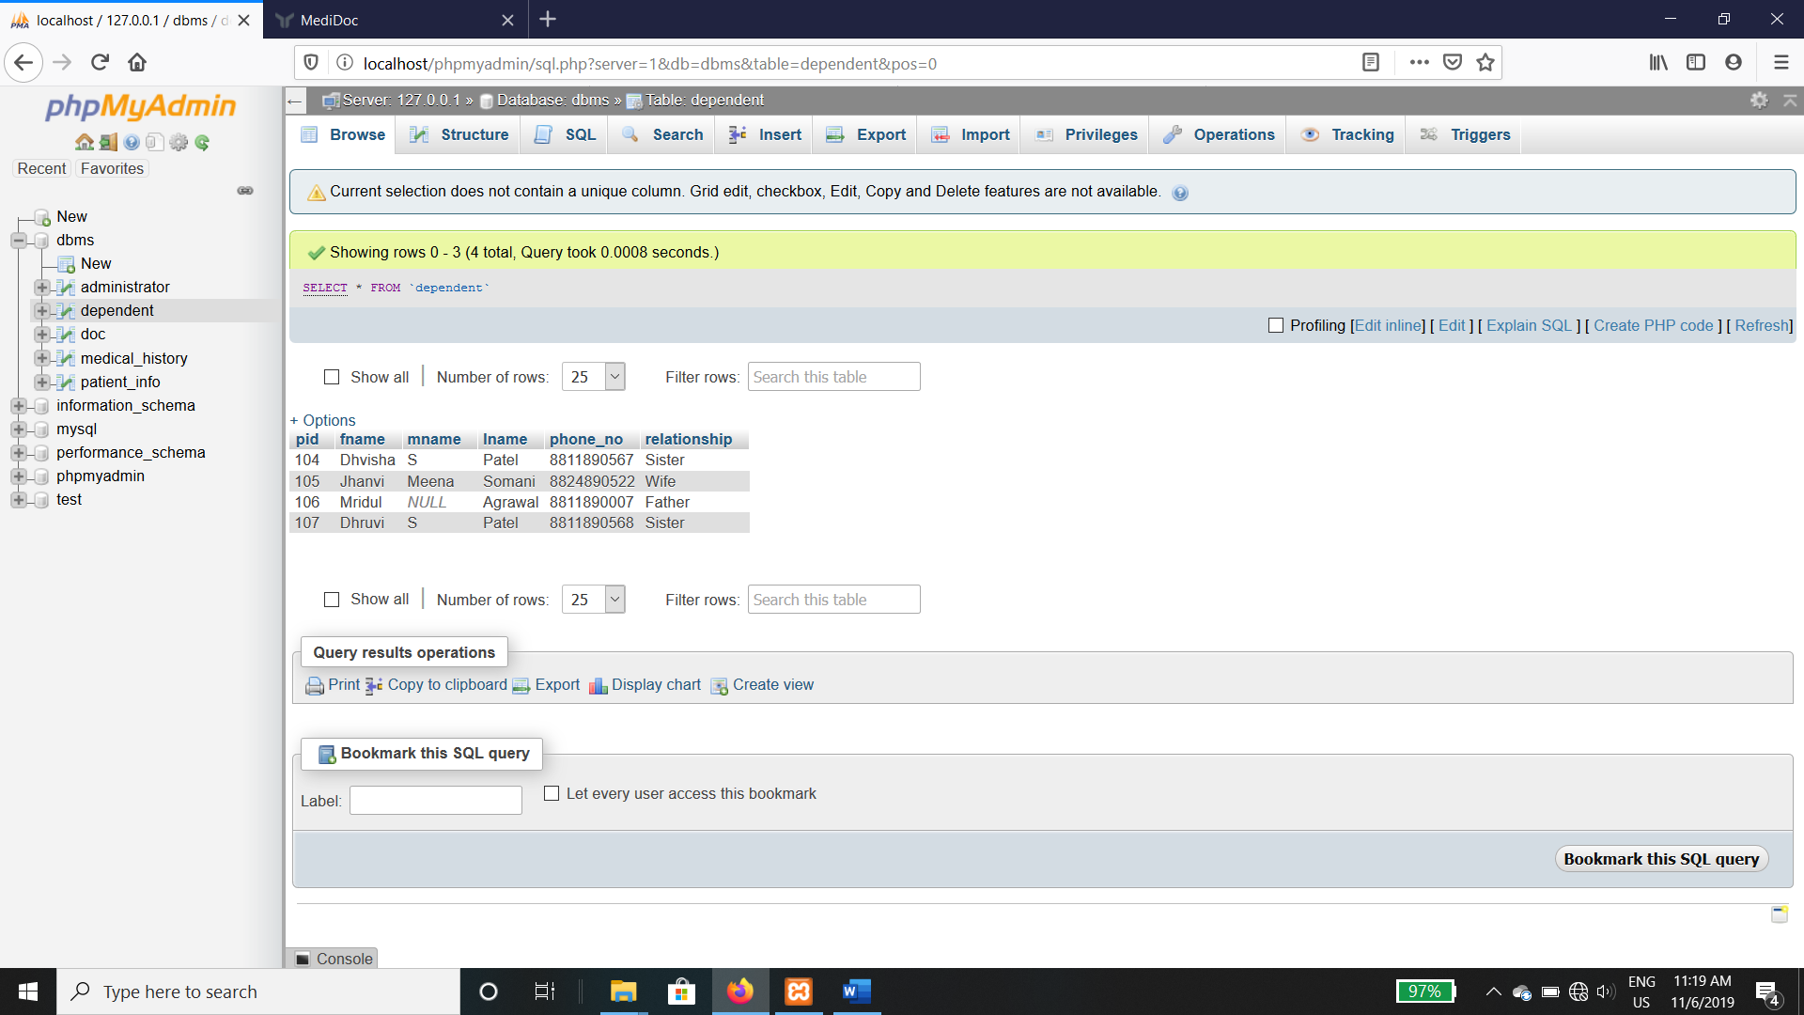

Fig 17

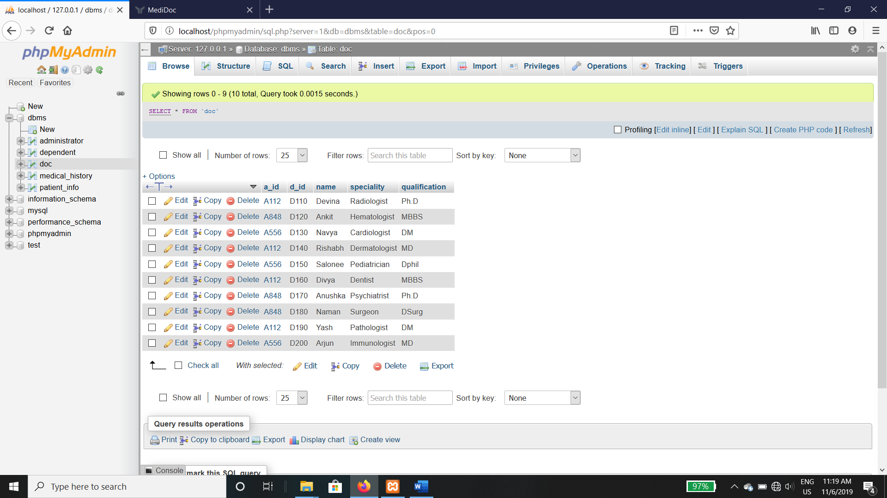

Fig 18

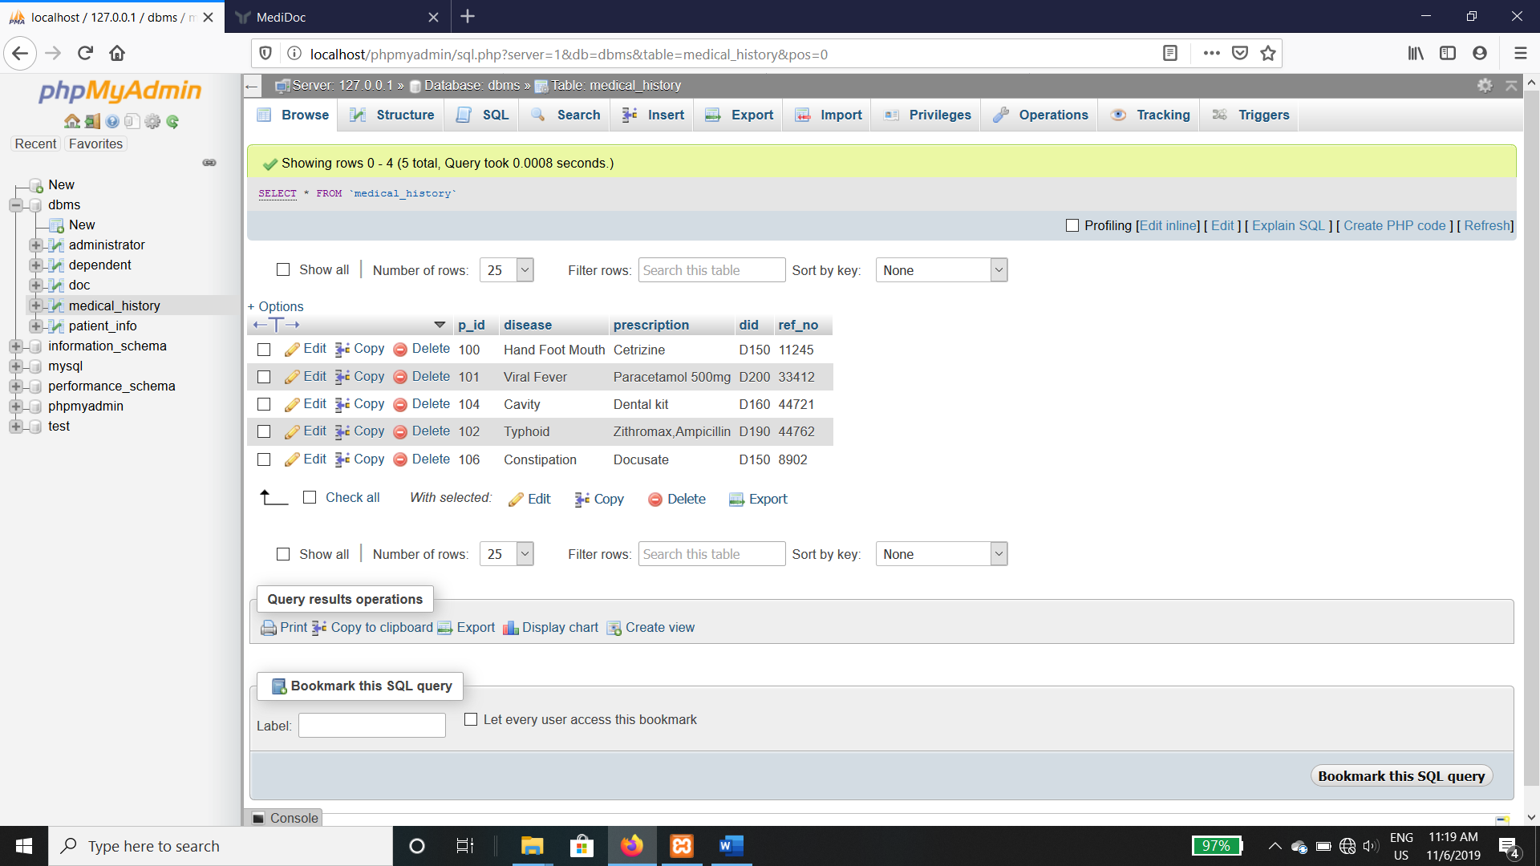

Fig 19

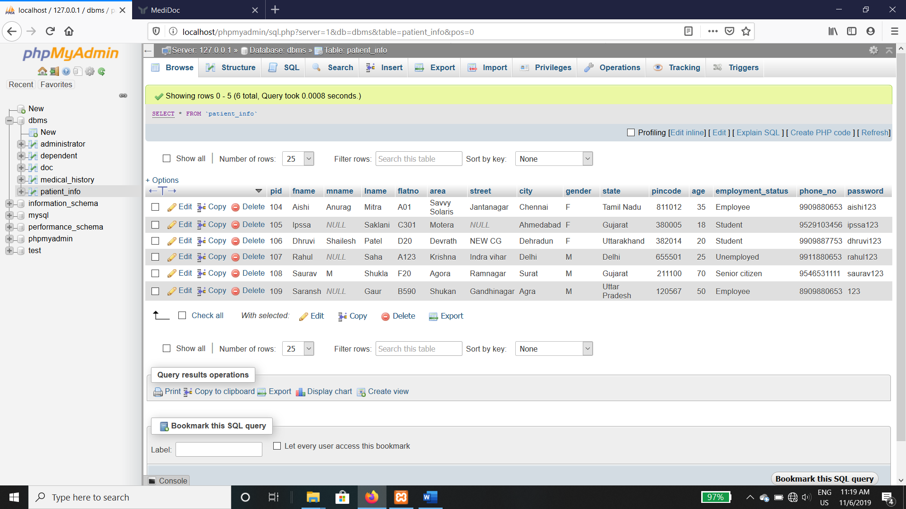

Fig 20

**Test Cases in terms of table or Graph**

Our platform uses dual authentication to ensure, that the patient records are never altered without the consent of a user as well as by any un-authorized personnel. This is ensured by our unique dual authentication, where in the hospital admin is supposed to put in the credentials of the hospital, which have been allotted by authorities of the central government of a country to verify whether the hospital is legitimate. Now, to modify the records of a patient, the admin is supposed to input the unique password of patient, which is later envisioned to become the OTP.

**Performance Analysis**

We know that the performance of a software or application is determined by the time taken by the most complex operation . Here, the most time taking operation is the fetching of data from the database. The complexity of fetching data from the database is found out to be O(log(n)) as we will be using B-Tree-esque organization to get to our record.

Fig 21: Dual authentication

In fig 21, neither the user nor the administrator has logged in. User 2 has logged in. Administrator 3 has logged in. User 4 and administrator both have logged in.

**Sample Code**

* Medical records have been stored using various methods from the beginning of medical sciences, this is to identify patterns of diseases in a certain individual to give better analysis of the underlying diseases that might be affecting the individual.
* Medical records currently are stored on the local database of the hospital one may visit. This leads to better analysis and less hassle on the part of the patient, as he/she might not always maintain a medical record on their own.
* The traditional medical records system in use right now, might be a pretty fine solution to this problem of maintaining medical records, but they would be of no use, if the patient decides to visit a different hospital or gets relocated to a new location. Now different hospitals base their systems on different operating systems. So building a platform specific software is not the answer. Thus this project is based on a universal web based platform which makes it accessible not on to the admins of all the hospitals across the country, but also to the patients. The common records that can be accessed by all the hospitals approved by central authorities is what makes this software seamless and makes it stand out as compared to the other solutions currently present.

**Conclusion and Future Work**

* While there are many improvements that can lead to a more transparent and seamless experience with medical records, MediDoc takes a step forward by unifying the Healthcare database of an entire country. This leads to a better experience for both the hospital admins and the patients. This also ensures that the healthcare schemes are not exploited by the patients by forging fake medical records.
* In later updates, we can incorporate health schemes by the government, as well as the IoT devices which might be used by the hospital. We shall also incorporate OTP as an additional authentication option, which solidifies the security of the system further.
* We can also use cloud computing and Artificial intelligence to analyse the various aspects of patients and detect some of the chronic diseases early, which leads to better treatment.
* We can also analyse the health backgrounds of the various ethnic and other diverse sub groups of people and develop recognizable patterns about their health conditions . We can also determine how much a disease affects our country and which cure works the best .

**References**

* Fay Chang, Jeffrey Dean, Sanjay Ghemawat, Bigtable: A distributed storage system for structured data, on Seventh Symposium on Operating System Design and Implementation, 2006.
* Harsha S. Gardiyawasam Pussewalage and Vladimir A. Oleshchuk “A Patient-Centric Attribute Based Access ControlScheme for Secur..e Sharing of Personal HealthRecords Using Cloud Computing” Dept. of Information and Communication Technology, University of Agder (UiA) 2016.
* F. Rezaeibagha, Y. Mu “Distributed clinical data sharing via dynamic access-control policy transformation ” International Journal of Medical Informatics 89 (2016) 25–3.
* Himanshu Taneja , Kapil“ Preserving Privacy of Patients based on Re-identification Risk “Procedia Computer Science 70 ( 2015 ) 448 – 454.